**Events Page**

**Our first featured event was a rousing success!**

**Unsealed Lips: Rum-Running and Violence in Berlin Township, 1918-1933**

**Thank you to Joe Boggs for a great presentation!**

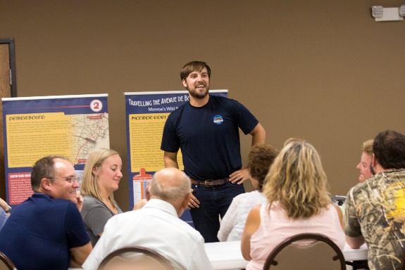

On September 5, 2018, Joe Boggs, who is a seventh-generation pioneer descendant of Berlin Township and a history teacher in Perrysburg, Ohio, gave an exciting and informative presentation on the “dry days” of Prohibition in Berlin Township, including Newport, South Rockwood, and Estral Beach. Over 60 history enthusiasts, both residents and non-residents, attended the fun and fascinating event.

“I would argue that Berlin Township and Newport specifically was perhaps the most important location during national prohibition in all of Monroe County,” Joe told us. “If you look at a map during the time period, the Dixie Highway runs very close to the water in Newport, allowing local boat rum-runners to unload illegal liquor quite easily…”

Based on his research in nearby archives and conversations with several of the area's most knowledgeable locals, Joe shared some of the more interesting stories from the region, including many familiar family names from the Berlin Township area.

If you missed this event, you can hear Joe’s presentation on our Facebook page. Look for the shared post, dated September 8, 2018.

~~~~~~~~~~~~~~~~

We’re looking to do MORE great events like this! Is there a topic related to Berlin Township history that you’d like to see showcased at our next event? Do you know someone who is well versed on a specific aspect of township history that would enjoy offering their insight and wisdom to an eager and interested crowd? Please contact us so we can make it happen! Feel free to call society president Stephanie Hawkins at 734-872-1226.

**Volunteer Page**

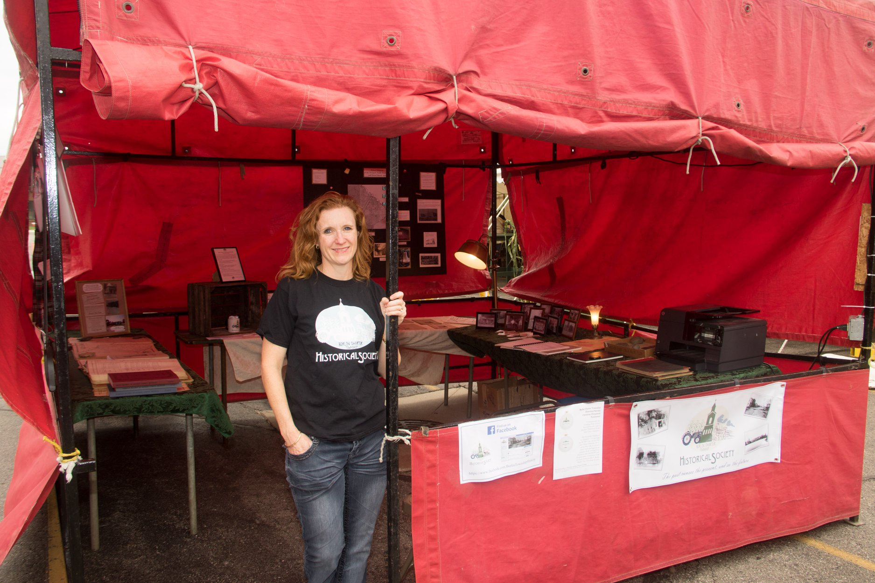

Are you interested in Berlin Township history? Would you like to engage with others to help promote our area’s rich history and aid in the preservation of it? Well, we have a spot for you!

Our new organization has many opportunities for volunteering. We’re looking for help in the following areas:

* **Programs, Meetings, and Special Events:** 
  + Brainstorming ideas for future events and programs to engage the community
  + Manning our booth at community events, such as local festivals
* **Publicity:** Working with local media to help us maximize publicity, such as sending press releases and photos to the paper
* **Ways and Means:** Coming up with creative and productive ways for us to raise funds
* **Membership:** 
  + Encouraging membership among township residents and former residents
  + Delivering membership documents to new members (certificates, cards, and charter member pins)
* **Curations:** helping acquire donations of historical items for the society’s collection

There are other ways you can help, too—many of which are very easy and require only a small time commitment. If you can offer a few hours or days each year to help our organization grow and thrive, please contact our volunteer coordinator, Stephanie Hawkins, at 734-872-1226, send an email to [info@berlintownshiphistory.org](mailto:info@berlintownshiphistory.org), or send us a message via our Facebook page ([www.facebook.com/berlintownshiphistory](http://www.facebook.com/berlintownshiphistory)).

**Contact Us Page**

**General Contact**

Looking to engage with the Berlin Township Historical Society? We’d love to hear from you!

For memberships, volunteer opportunities, future event/program suggestions, or just general questions, please feel free to call (734-872-1226) or email ([info@berlintownshiphistory.org](mailto:info@berlintownshiphistory.org)) us.

**Donations**

We are accepting donations of items that directly relate to Berlin Township history (including the villages of South Rockwood and Estral Beach, as well as the general unincorporated area of Newport). If you have an item you wish to donate, please contact us via phone (734-872-1226) or email ([info@berlintownshiphistory.org](mailto:info@berlintownshiphistory.org)). We reserve the right to decline donations that do not directly relate to Berlin Township history or for which we do not have appropriate storage.

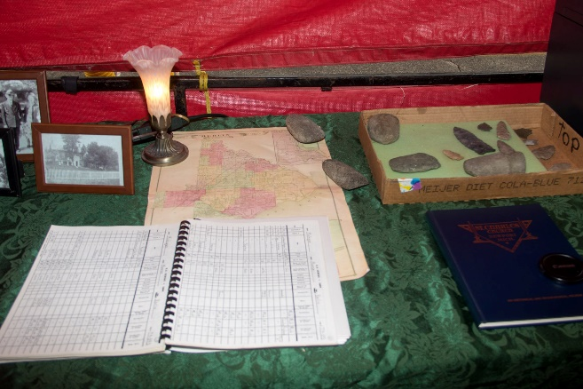

Berlin Charter Township Historical Society is a Michigan Non–Profit Corporation and is a Federal IRS 501(c)(3) tax exempt organization. Donations to the organization are tax-deductible as allowed by law. Please consult your tax advisor for more information.

Thank you for your interest in Berlin Charter Township history!